EX. NO. 1 | Implementation of a basic Reinforcement Learning environment with OpenAI Gym
DATE:

AIM:
To implement a basic Reinforcement Learning environment using OpenAI Gym and train an agent using Q-learning to solve the FrozenLake environment and visualize the optimal path using animation.
ALGORITHM:
- Import required libraries such as NumPy, Matplotlib, Random, and Gymnasium.
- Initialize hyperparameters including number of episodes, learning rate (α), discount factor (γ), and exploration rate (ε).
- Create the FrozenLake environment and initialize the Q-table with zeros for all states and actions.
- For each episode, reset the environment and choose actions using the ε-greedy policy.
- Perform actions, observe the next state and reward, and update the Q-table using the Q-learning update rule.
- After training, test the agent using the learned Q-table and visualize the optimal path using animation.
PROGRAM:
import numpy as np
import matplotlib.pyplot as plt
import matplotlib.animation as animation
from IPython.display import HTML, display
import random
import gymnasium as gym
EPISODES, ALPHA, GAMMA, EPSILON = 2000, 0.8, 0.95, 0.5
def train_agent():
env = gym.make("FrozenLake-v1", map_name="4x4", is_slippery=False)
q = np.zeros((env.observation_space.n, env.action_space.n))
for _ in range(EPISODES):
s, _ = env.reset()
done = False
while not done:
a = env.action_space.sample() if random.random() < EPSILON else np.argmax(q[s])
ns, r, term, trunc, _ = env.step(a)
done = term or trunc
q[s,a] += ALPHA * (r + GAMMA * np.max(q[ns]) - q[s,a])
s = ns
env.close()
return q
def test_and_animate(q):
env = gym.make("FrozenLake-v1", map_name="4x4", is_slippery=False, render_mode="rgb_array")
s, _ = env.reset()
frames = [env.render()]
done = False
while not done:
s, _, term, trunc, _ = env.step(np.argmax(q[s]))
frames.append(env.render())
done = term or trunc
env.close()
fig, ax = plt.subplots()
plt.axis('off')
ims = [[ax.imshow(f, animated=True)] for f in frames]
anim = animation.ArtistAnimation(fig, ims, interval=500)
plt.close()
display(HTML(anim.to_jshtml()))
if __name__ == "__main__":
q = train_agent()
test_and_animate(q)

OUTPUT:
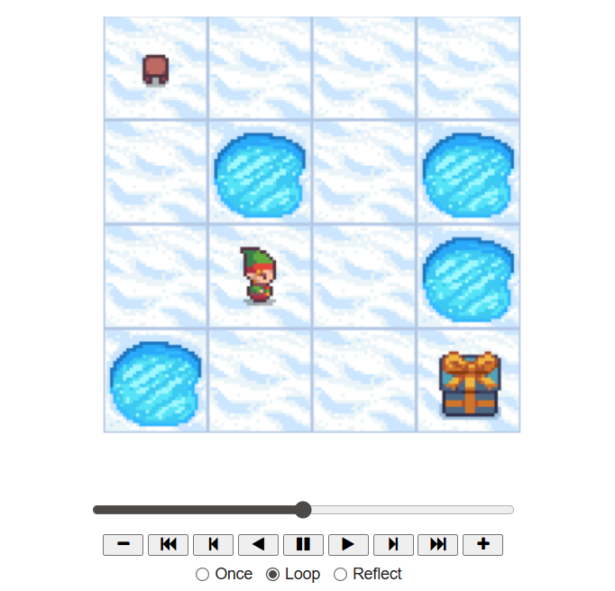

S.No | Particulars | Max Marks | Marks Obtained
1. | Aim and Algorithm | 5
2. | Program and Execution | 10
3. | Viva | 10
4. | Total | 25

RESULT:
Thus, the Q-learning algorithm was successfully implemented using OpenAI Gym, and the agent successfully learned to reach the goal in the FrozenLake environment.

